**CST-339 Programming in Java III**

**Project Status and Design Report**

|  |  |  |
| --- | --- | --- |
| **Topic:** | 1. *Introduction to Spring* Boot | |
| **Date:** | *23 February 2025* | |
| **Revision:** | *1.0* | |
| **Team:** | 1. Elijah Kremer | |
| 1. James Shonk | |
|  | |
|  | |
| **Weekly Team Status Summary:** | |  |  |  |  | | --- | --- | --- | --- | | **User Story** | **Team**  **Member** | **Hours**  **Worked** | **Hours Remaining** | | *Planning* | *Both* |  |  | | *Setting user stories for the project* | *Both* |  |  | | *Designing sitemap, classes, database* | *Both* |  |  | | *Creating a detailed project proposal* | *Both* |  |  | | *This Project is highly collaborative so we plan to work together.* |  |  |  | |  |  |  |  | | |
| **GIT URL:** | *https://github.com/ElijahKKremer/CST339/tree/main* | |
| **Screencast URL:** | *Part 1:* [*https://www.loom.com/share/b0fd00d0a6744058a3138dd804c82d2b*](https://www.loom.com/share/b0fd00d0a6744058a3138dd804c82d2b)  *Part 2: https://www.loom.com/share/a8088741047e40eaa12e86f49d0ce9bc* | | https://www.loom.com/share/b0fd00d0a6744058a3138dd804c82d2b |
| **Peer Review:** | *Y* | We acknowledge that our team has reviewed this Report, and we agree to the approach we are all taking. |

**Planning Documentation**

**Initial Planning:**

*The team agreed on developing an e-commerce website within the Phone market. Created documentation, and delegated tasks to team members. Came up with the approach and sitemap diagram.*

*(This can be any task lists or sprint planning you completed to complete this assignment. )*

**Retrospective Results:**

*The following table should be completed after each Retrospective on things that went well (keep doing).*

|  |
| --- |
| **What Went Well** |
| App Design – Effective communication amongst the team in regard to planning the web app. |
| Team Approach – We both effectively agreed on what needed to happen as well as how we would accomplish our goals. |
|  |

*The following table should be completed after each Retrospective on things that didn’t go well (stop doing) and what would be done differently next time with an action plan to improve (try doing and continuous improvement).*

|  |  |  |
| --- | --- | --- |
| **What Did Not Go Well** | **Action Plan** | **Due Date** |
| This first week we were both fairly busy and didn’t get the majority of the work done until the end of the week. | Make an effort to get as much work done earlier in the week as possible. |  |
|  |  |  |
|  |  |  |

**Design Documentation**

**Install Instructions:**

*Step-by-step instructions for setting up your database, and configuring and deploying/installing your application. This section should also include detailed instructions for what configuration files are required by your application, what configuration settings need to be adjusted for various runtime (development or production) environments, and where the files need to be deployed to. This section should also contain detailed instructions for how to clone your application source code from GIT and deploy the application to an externally hosted site.*

- Install all necessary programs if not already done.

- Configuration and setup, adjust application.properties

- Run database migration

- App setup and development

- cloning

- build application

- product development

- packaging

**General Technical Approach:**

*You should, in words, describe your approach and design here. You should also summarize any meeting notes, brainstorming sessions, etc. that you want to retain through the design of your project.*

Our team aims to develop a user-friendly and visually appealing e-commerce website for online product sales. The platform will enable users to browse and purchase items, create and manage product listings, view detailed product information, and update or remove existing products.

**Key Technical Design Decisions:**

*Any final technical design decisions, such as framework decisions, should be documented here. This should list the technology/framework, its purpose in the design, and why it was chosen.*

We will provide a document containing the resources we plan on using for this project. These choices are made due to our past experiences and will allow us to have familiarity with design and development of the project.

**Known Issues:**

*Any anomalies or known issues in the code or functionality should be documented here.*

We are unsure of any anomalies or known issues at the moment.

**Risks:**

*The project scope may become overly ambitious given the limited timeframe, and there is a potential risk of insufficient security for user payment and transaction data.*

**ER Diagram:**

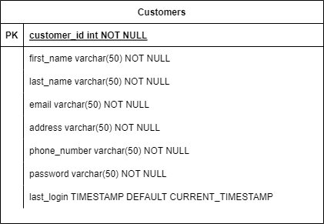

**DDL Scripts:**

*This should contain a link to Bitbucket wherefrom the DDL script can be downloaded.*

**Sitemap Diagram:**

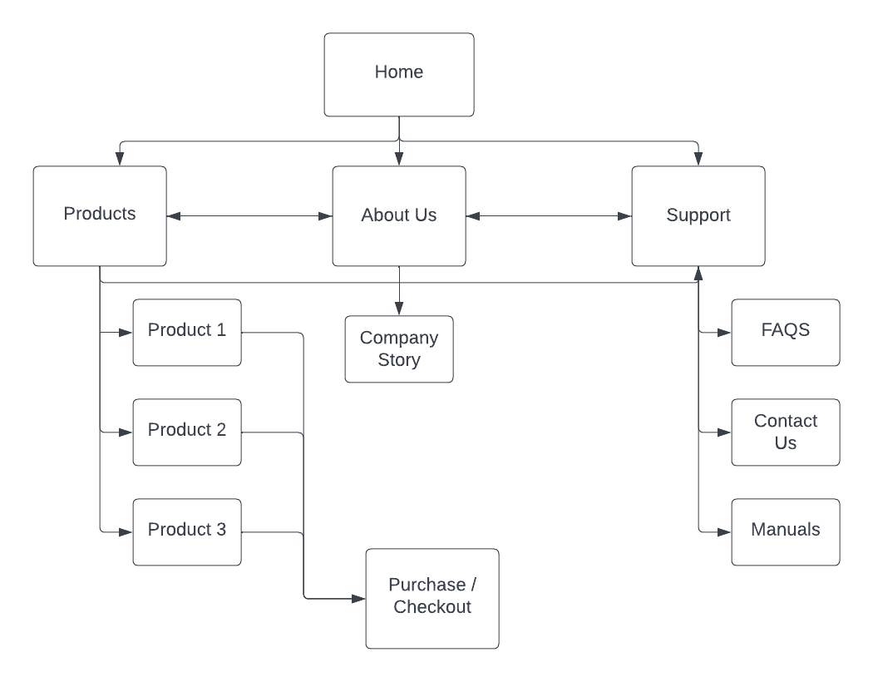

**User Interface Diagrams:**

*You should insert any wireframe drawings or whiteboard concepts that were developed to support your application. If you have no supporting documentation, please explain the rationale for why you are able to leave this section as N/A.*

**Class Diagrams:**

*You should insert any class diagrams here. Your class diagrams should be drawn correctly with the 3 appropriate class compartments, + and – minus to indicate accessibility, and also the data types for the state/properties as well as method arguments and return types. If you have no supporting documentation, please explain the rationale for why you are able to leave this section as N/A.*

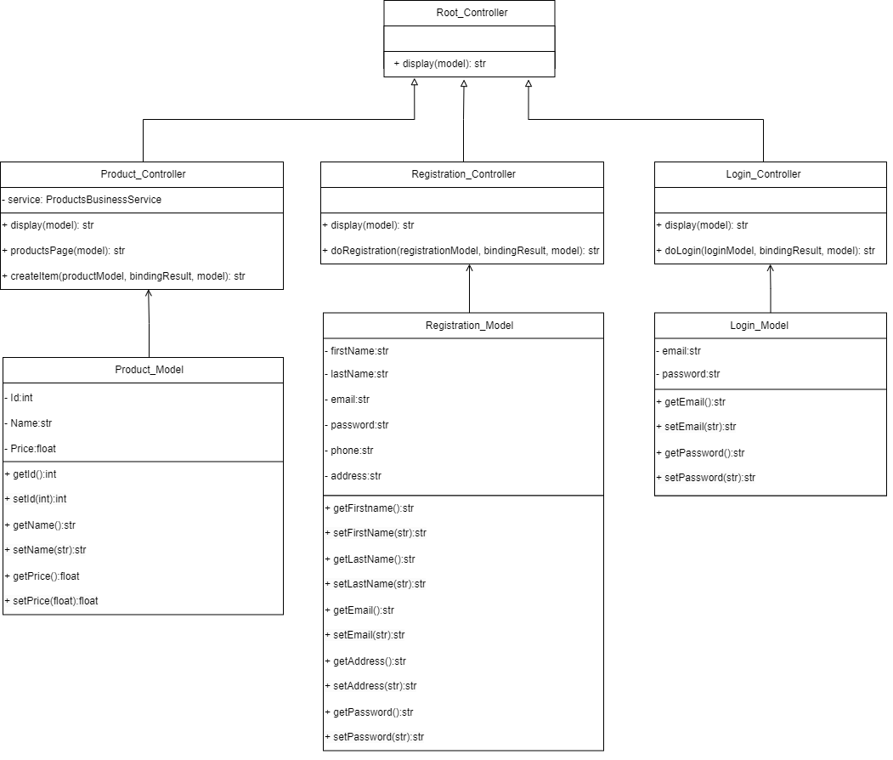

**Service API Design:**

*This section should fully document any service API’s (like REST API’s) that are being published, how to access the service, what parameters are required by the API, and the detailed JSON data format specification that could be used by a third party developer to integrate with the service and API. The design can also be captured with tools such as Swagger.*

**Security Design:**

*This section should outline the design for how authentication and authorization was supported. This section should also contain all of the roles and privileges that are supported by the design.*

- We will provide secure login features

- User registration

- password protection

- roles and privileges will be held to customers, admin, and vendor

**Other Documentation:**

*Project Proposal Below This assisted us in planning out or SQL Database and design concepts:*

**Goals**

* Build a secure, scalable, and intuitive e-commerce platform.
* Design a responsive layout optimized for both desktop and mobile users.
* Enable product browsing with advanced search and filtering options.
* Implement user account creation and authentication.
* Develop a secure login module.

**Key Features**

* Search and filter functionality for phones.
* Add-to-cart and checkout process.
* User authentication and account management.

**Target Audience**

Our primary audience consists of tech-savvy shoppers looking for detailed information to make informed decisions when purchasing an Android phone.

**Timeline**

The project will be developed over eight weeks, starting in the first week of class and concluding in week 8.

* **Week 1:** Planning and design
* **Weeks 2-7:** Development and testing
* **Week 8:** launch

**Conclusion**

This project presents a valuable learning opportunity for our team, allowing us to gain hands-on experience with securing web applications, managing databases, and building a functional e-commerce platform.